**PROJECT PROFILE**

|  |  |
| --- | --- |
| **Project Name** | **Carzonrent** |
| **Objective** | It is a system design especially for large, premium and small car rental business.  The car rental system provides complete functionality of listing and booking car.  In this system, Tourism and Travelling facilities also provide. |
| **Platform** | Website |
| **Front End** | C#.NET |
| **Back End** | SQL |
| **Other Tools** | MS Office 2007,Data Report , Visual Studio 2010 |
| **Project Duration** | 90 Days |
| **Internal Guide** | Miss.B.T.Patil |

**\*INTRODUCTION\***

This website is designed so as to be used by Rental Company specializing in renting cars to customers. System includes different categories of cars like four-wheeler. Again, four wheelers are categories according to different types of companies. Four-wheeler cars contain types like Hatchback, SUV, Sedan, and Luxury.

It is the system through which customers can get information about cars, their availability and information about their rents. Using this information customer can able to book the cars and pays rent to company. There is booking cars available where user can add multiple cars.

Customers are also able to cancel their booking from this website with refund amounts. There is a cancelation and refund policy for each type of cars. Users are also able to give feedback about website and able to give their experience feedback.

This information is managed by admin. Customer can able to book vehicles of their choices from these systems which are available. There is another user called manager who updates the cars availability from different locations.

**\*OBJECTIVES\***

* The new system is totally computerized system.
* New system provides features like time efficiency to show cars details, user profiles and whatever the customer will give the feedback to the admin.
* An inquiry is easily done by user in the system.
* It is the most software application for managing online vehicle rental business.
* If customer requires the driver then we can provide the drivers to the customer.
* We can gives offers to the customer in formed f cash discount or % discount.
* We give option to the admin panel for add promos in form of % discount or in cash discount.
* Manager can locally handle to the branch and receive and send the cars.
* All system is correctly calculated the vehicles rent cost and generate the bill.
* You can access the website in your desktop as well as mobile.
* You can easily book, cancel and expand period of cars.

**\*EXISTING SYSTEM\***

* An existing system can provide manually paper work. Customer has to go the office where admin provide the information about the vehicles and booking details to customer.
* Admin get the available vehicle information and booking information from their book registers. It is very lengthy work. Here information registers (information books) can be viewed by any persons.
* For storing large amount of data many registers may require to calculate.
* To calculate bills by subtracting discounts and adding taxes and other charges is time consuming & mistakes may happen so computerized rent management system is required.

**\*LIMITATIONS\***

* Details are stored in papers.
* Maintenance is a huge problem.
* Updating, changes & details is tedious task.
* Performance is not achieved up to the requirements.

**\*PROPOSED SYSTEM\***

* A new system provide feature like time efficiency to show cars details, booking details and the information required to book a car.
* An enquiry easily done by user in the system. It is easy to do booking cars whenever needed. Bills are easily calculated. Admin can able to view various report using the system.
* Admin can add the cars, manager, driver &promos (offers). Admin can generate the promos code throw add promos.
* Manager can allocate the driver to the customer id driver is required to the customer.
* Manager can take pictures and upload the pictures before the car gives to the customer and after delivery it can check the condition of cars.
* Manager can take pictures and upload the pictures before the car gives to the customer and after delivery it can check the condition of cars.
* It verifies the customer and their documents before to give key of cars.

**\*ADVANTAGES\***

* Data is centralized which has overcome the sharing problems in previous system.
* As data is maintained electronically it’s essay for person to updating the details which has overcome the tedious updating in pervious system.
* Maintenance is essay and performance is good.
* Mainly the system is automated the transportation system.

**Software Requirement Specifications**

**2.1 Software requirement**: **Introduction to VB.NET**

**What is .Net?**

.Net is a set of s/w technology for connecting information, people, systems & devices. .Net word says that it is related to internet.

**Definition:**

It is a platform which is used to compile & execute programs written by using .Net compatible languages.

**.NET Framework**

**Blocks of Framework Architecture**:

1. .Net Compatible Languages
2. Common Language Specification
3. Common Type System
4. Common Language Runtime
5. Frame
6. work Class Library

**1) .Net compatible languages: -**

vb.net, c#.net, jscrirt.net, VC++.net are languages compatible to .net framework.

**2) Common language specification: -**

These are set of rules defined for .net compatible languages. It helps to enhance & insure language interoperability by defining a set of features that developer can really on to the available in wide variety of languages.

If your components use CLS features in API that it exposes to other code, his component is garneted to be accessible from any programming language that supports CLS. The CLS was design to large enough to include language constructs that are commonly needed by developers.

E.g. whenever a particular class is to be used then the respective namespace must be included. The system namespace is root namespace for fundamental type in the .net framework. This namespace include classes that represent the best data type used by all applications. E.g. Object, byte, char, array, int32, string etc

**3) Common type system:**

It is a part of CLS. The CLS performs following functions:

* Establishes a framework that helps cross language integral type safely & high performance code execution.
* Provide an object oriented model that supports the complete implementation of many programming language.
* Define rules that language must be follow which helps to insure that5 object written in different languages can interact with each other.

e.g. Dim I as integer(VB) into i (C#) 4 bytes 4 bytes System int 32

**4) Framework class library (FCL): -**

.Net supports collection of predefined classes. These classes put under hierarchy of special structure called as Namespaces (collection of classes).In .net “System” is highest level namespace.

Whenever you start any .net application three namespaces

1) System

2) System. DATA

3) System. XML are included

The system namespace is root namespace for fundamental type in the .net framework. This namespace include classes that represent the best data type used by all applications. E.g. Object, byte, char, array, int32, string etc.

**5) Common Language Runtime (CLR):-**

CLR is the heart of .net framework. It takes care of entire execution, Memory management of .net application irrespective of type of application it is also called as managed execution environment.

The .NET Framework provides a run-time environment called the **Common Language Runtime**, which manages the execution of code and provides services that make the development process easier. Compilers and tools expose the runtime’s functionality and enable you to write code that benefit from this Managed execution environment. Code that you develop with a language compiler that targets the runtime is called managed code; it benefits from Features such as cross language integration, cross-language exception handling, enhanced security, versioning and deployment support, a simplified model for component interaction, and debugging and profiling services.

**2.2 Database requirement - Introduction to SQL**

**Back End:-**

**Introduction to SQL (Structured Query Language):-**

**SQL** (Structured Query Language) is used to perform operations on the records stored in the database such as updating records, deleting records, creating and modifying tables, views, etc.

**Features of SQL:-**

* **SQL** is easy to learn.
* **SQL** is used to access data from relational database management systems.
* **SQL** can execute queries against the database.
* **SQL** is used to describe the data.
* **SQL** is used to define the data in the database and manipulate it when needed.
* **SQL** is used to create and drop the database and table.
* **SQL** is used to create a view, stored procedure, function in a database.
* **SQL** allows users to set permissions on tables, procedures, and views.
* Using the **SQL** queries, the user can quickly and efficiently retrieve a large amount of records from a database.
* Designing a database.
* Creating and customizing tables.
* Creating and customizing query.
* Securing and administering a database.

**2.3FEASIBILITY STUDY**

In preliminary investigation feasibility study has three aspects.

1. Technical Feasibility

2. Operational Feasibility

3. Economical Feasibility

**1. Technical Feasibility:**

Technical issues involved are the necessary technology existence, technical guarantees of accuracy, reliability, ease of access, data security, and aspects of future expansion.

i. Technology exists to develop a system.

ii. The proposed system is capable of holding data to be used.

iii. The proposed system is capable of providing adequate response and regardless of the number of users.

iv.The proposed system beingmodular to the administrator, if he/she wants can add more features in the future and as well as be able to expand the system.

v. As far as the hardware and software is concerned, the proposed system is completely liable with proper backup and security

Hence, we can say that the proposed system is technically feasible.

**2. Operational Feasibility:**

If the system meets the requirements of the customers and the administrator we can say that the system is operationally feasible.

The proposed system will be beneficial only if it can be turned into a system which will meet the requirements of the store when it is developed and installed, and there is sufficient support from the users.

i. The proposed system will improve the total performance.

ii. Customers here are the most important part of the system and the proposed system will provide them with a convenient mode of operation for them.

iii.The proposed system will be available to the customers throughout the globe.

iv. The proposed system will provide better market for different dealers.

Hence, the proposed system is operationally feasible.

**3. Economical Feasibility:**

Economic Feasibility is the most frequently used method for evaluating the effectiveness of the proposed system if the benefits of the proposed system outweighs. The cost then the decision is made to design and implement the system.

i. The cost of hardware and software is affordable.

ii. High increase in the amount of profit earned by going global.

iii. Easy and cheap maintenance of the system possible.

Hence, the proposed system is economically feasible

**Software Requirements:**

* IDE **:**  Microsoft Visual Studio 2010
* Operating System **:**  Windows 7/10
* Project Platform **:**  .NET
* Framework **:**  Framework 3.5
* Front End  **:**  ASP.NET with C#
* Back End **:**  SQL Server 2008

**Hardware Requirements:**

* PROCESSOR  **:**  Intel Pentium 4.1GHz processor
* RAM **:** 512 MB SDRAM
* HARD DISC SPACE **:** 80GB & above
* PRINTER **:** Dot Matrix / Ink Jet
* MONITOR **:** Color or Monochrome

**\*Data flow Digram\***

**[dfd]**

DFD is also known as ‘Bubble Chart’. Its purpose is to classify system requirement and identifying major transformation that will become program in a system design. So, it is a starting point of the design phase that functionality decomposes the requirements specifications down to the lowest level of the detail. A DFD consists of series of bubbles joined by lines. The bubbles represent data transmission and line represents data flow in the system.

**\*context level dfd:**

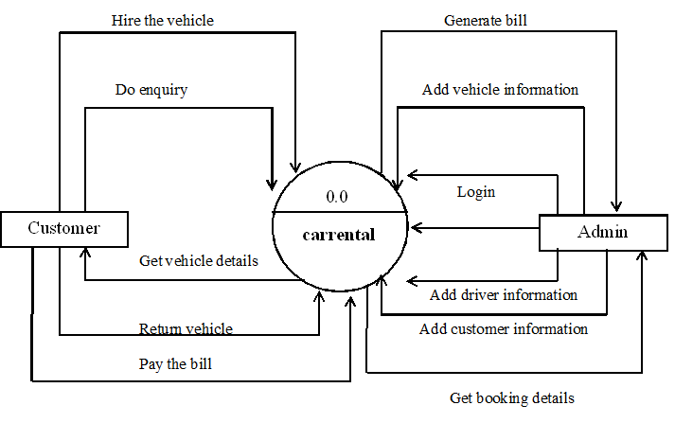

**\*first level DFD:**

**Customer:**

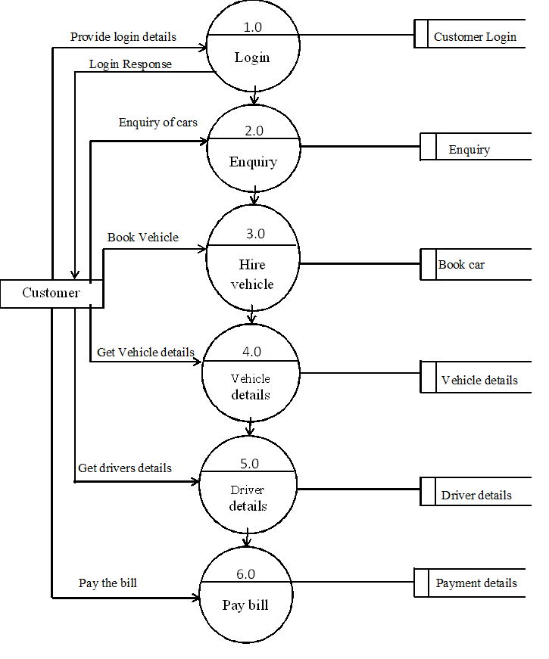

**Admin:**

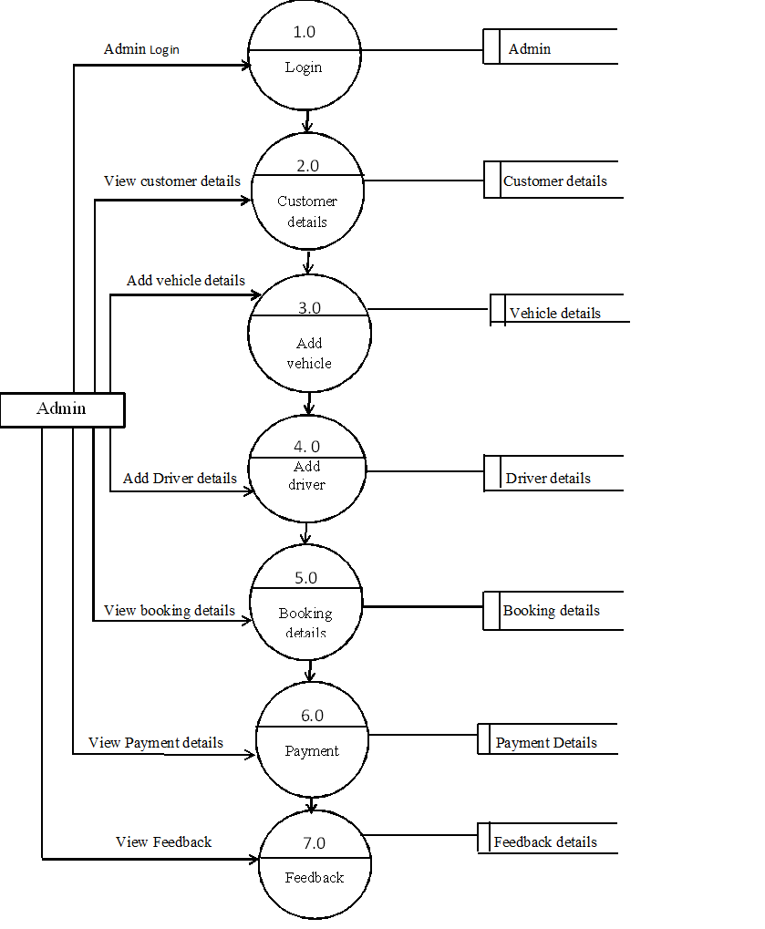

**\*Entity Relationship Diagram [ERD]**

Entity relationship diagram graphically represent overall logical structure of database which includes interactions between entity of various ways. Entityu relationship (ERD) illustrates the logical structure of database. Entity relationship ERD’s in 1976 since then Charles Bachman and James Martin have added some slight refinements to the basic ERD principles.

**\*E-R Model:**

E-R model is detailed logical representation of entities, Association and elements for an organization and business area.

**\*E-R Diagram:**

E-R diagram is a graphical representation of an E-R Model.

This model uses 3 features to describe data. These are as follows:

**1. Entity**

**2. Relationship**

**3. Attribute**

* **Entity:** An entity is a person, place, object, event or concept which system wants to store data.
* **Relationship:** It connects entities and represents meaningful dependency between them.
* **Attributes:**  It specifies properties of entities and relationship. Entity Relationship Diagram consists of different entities like supplier, owner, customer and stock. This ERD is very easy to understand. Because, in this ERD every entity has different attributes. In ERD these attributes can give the total work or total information of the system. In this candidate registered on the website. Then candidate apply for the job. Admin view job applied by candidate.

**\*Entity Relationship Diagram [ERD]\***

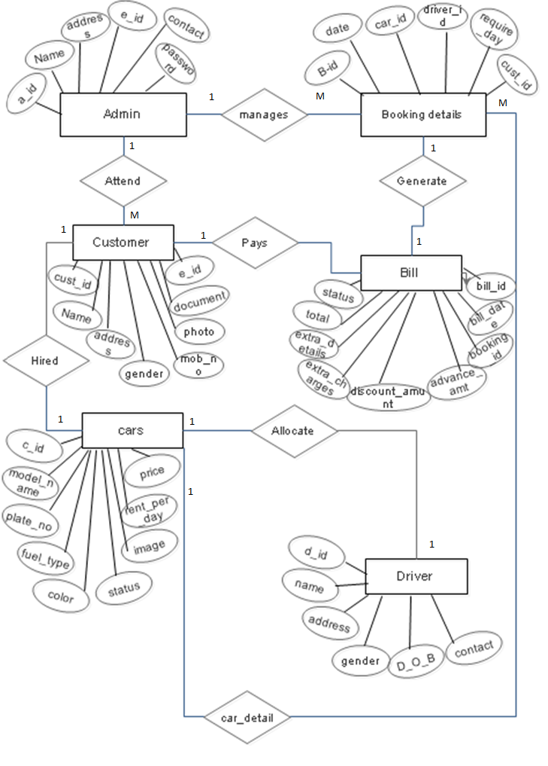

**\*Usecase diagram [uml]\***

**\*Admin:**

**Manages Website**

**Add Admin info.**

**Add Car info.**

**Add Driver info.**

**View enquiry**

**Manage Booking**

**Generate Bill**

**Reports**

**Logout**

**Admin**

**\*Customer:**

**Search cars**

**View Car info.**

**View Driver** **info.**

**Get booking details**

**Reserve car**

**Return the car**

**Pay the bill**

**Customers**

**\*SITE MAP DIAGRAM\***

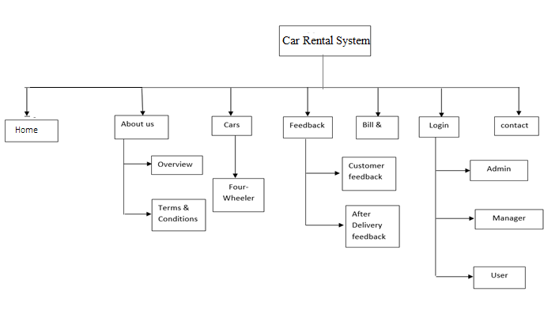

**\*ACTIVITY Diagram\***

**1. Activity diagram for login onto the system:**

Enter user Id and password

Verify password

incorrect

correct

Access granted

Car Manager

Driver Manager

Booking Manager

Customer Lookups

View Enquiry

View Feedback

Report

**2. Activity diagram for parents:**

Home

About Us

Cars

Chauffeurs

Terms

Feedback

Help Desk

**Data base**

**Design**

**Table Name: Admin**

**Description: - To store all Login ID and Password**

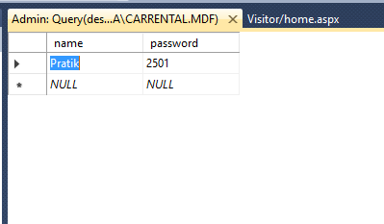

**Table Name: Cars**

**Description: - To store all Cars Details**

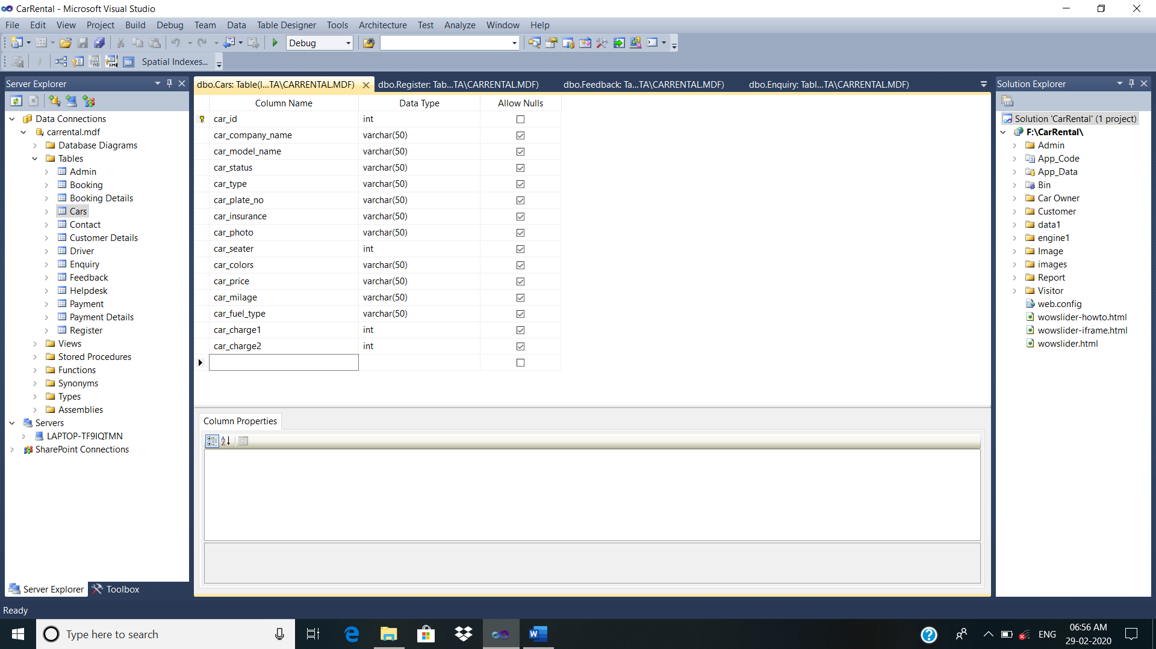

**Table Name: Driver**

**Description: - To store all Driver Details**

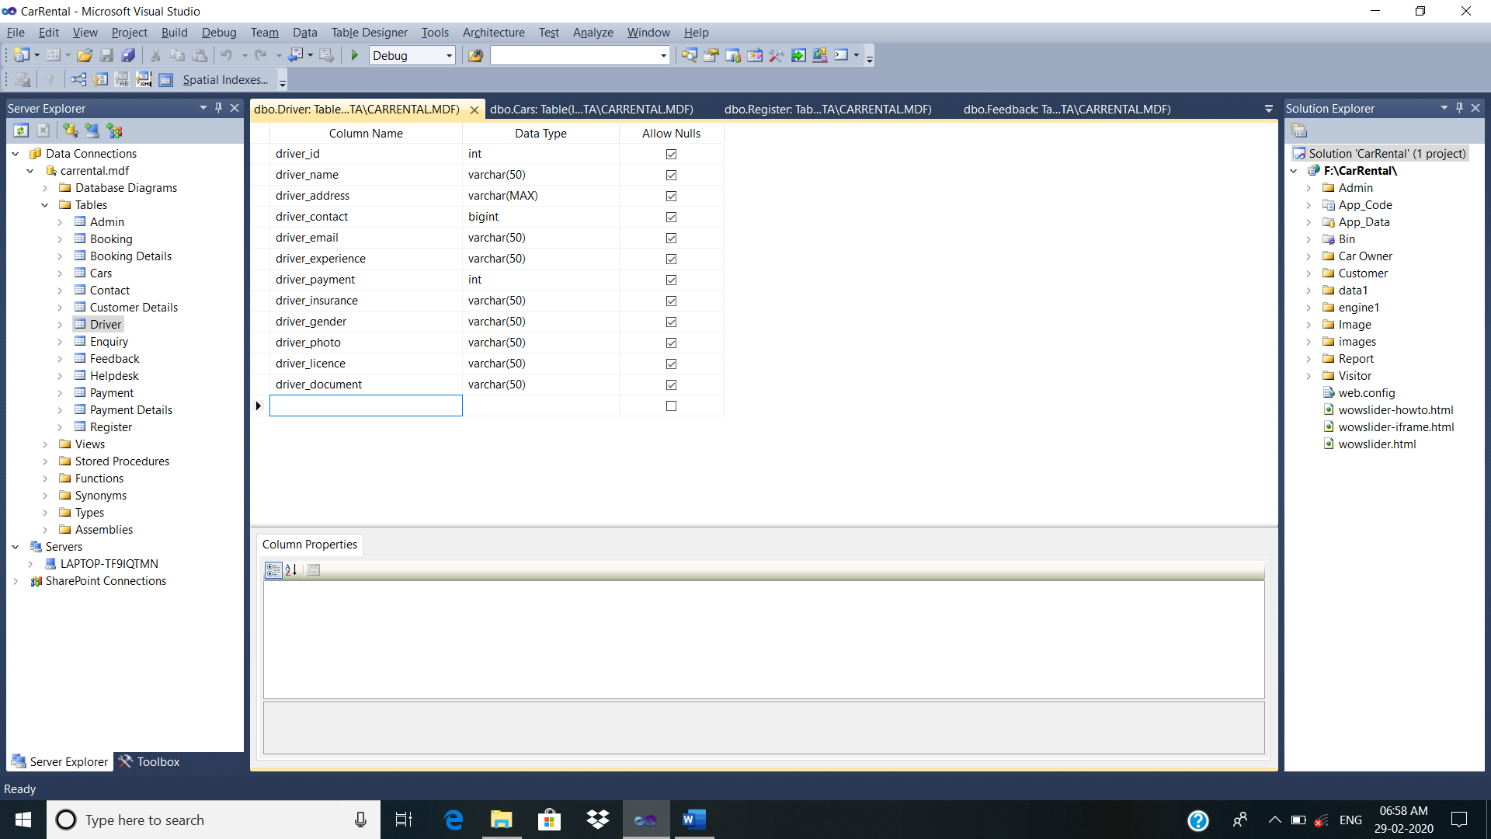

**Table Name: Booking Details**

**Description: - To store all Booking Details**

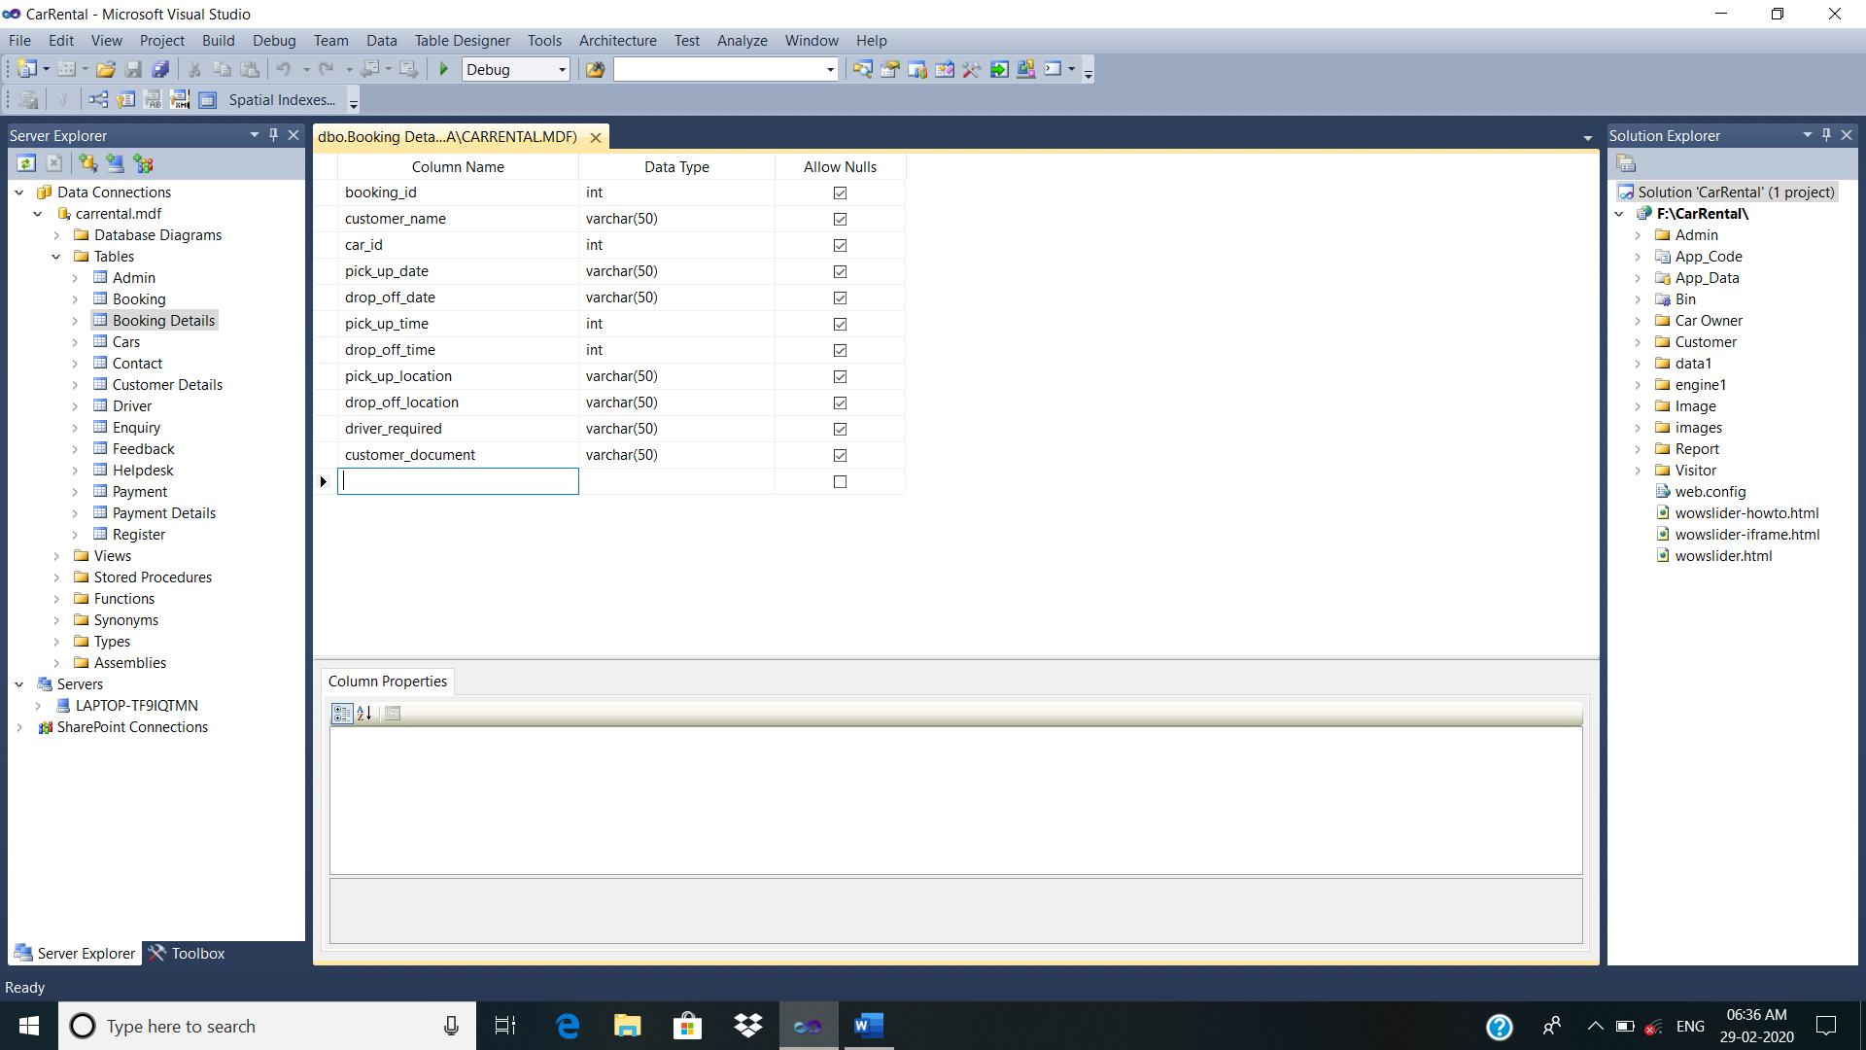

**Table Name: Customer Details**

**Description: - To store all Customer Details**

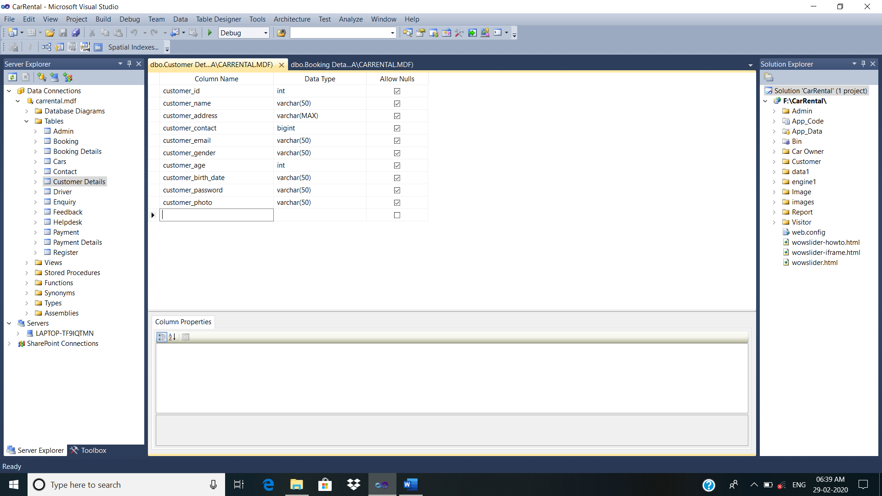

**Table Name: Payment Details**

**Description: - To store all Payment Details**

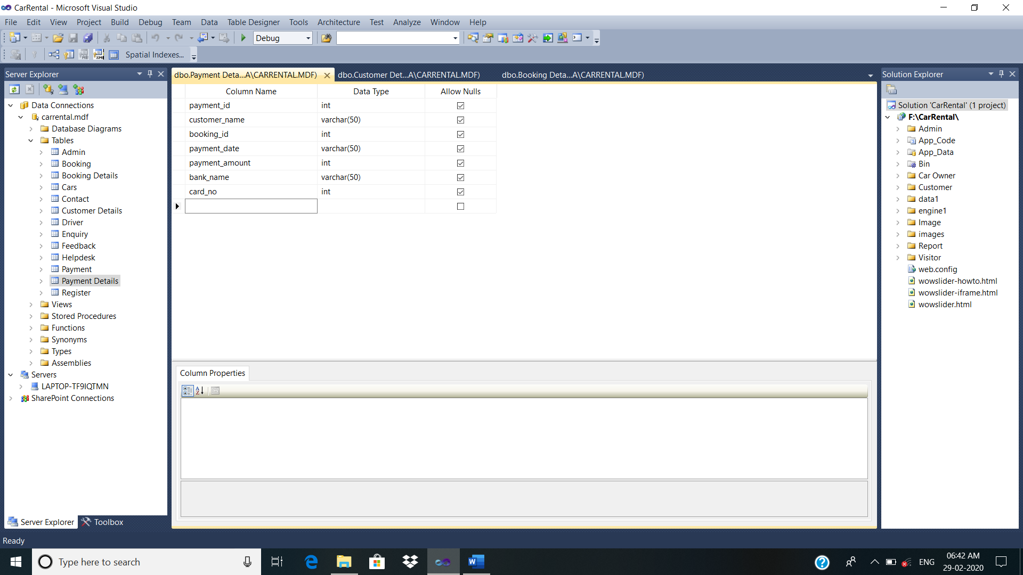

**Table Name: Contact**

**Description: - To store all Contact Details**

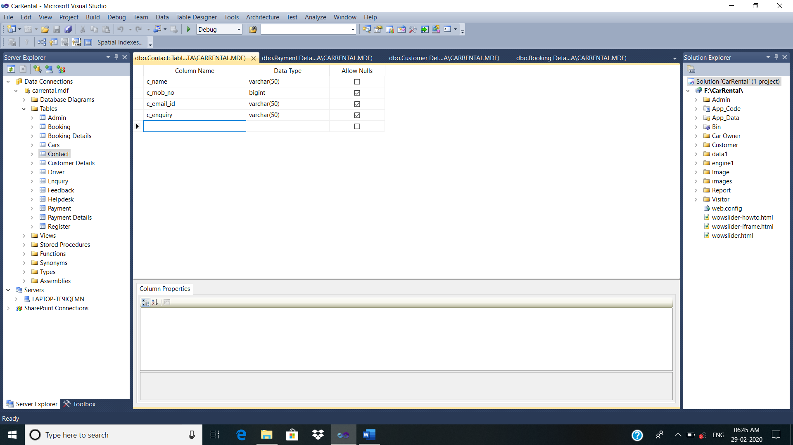

**Table Name: Enquiry**

**Description: - To store all Enquiry Details**

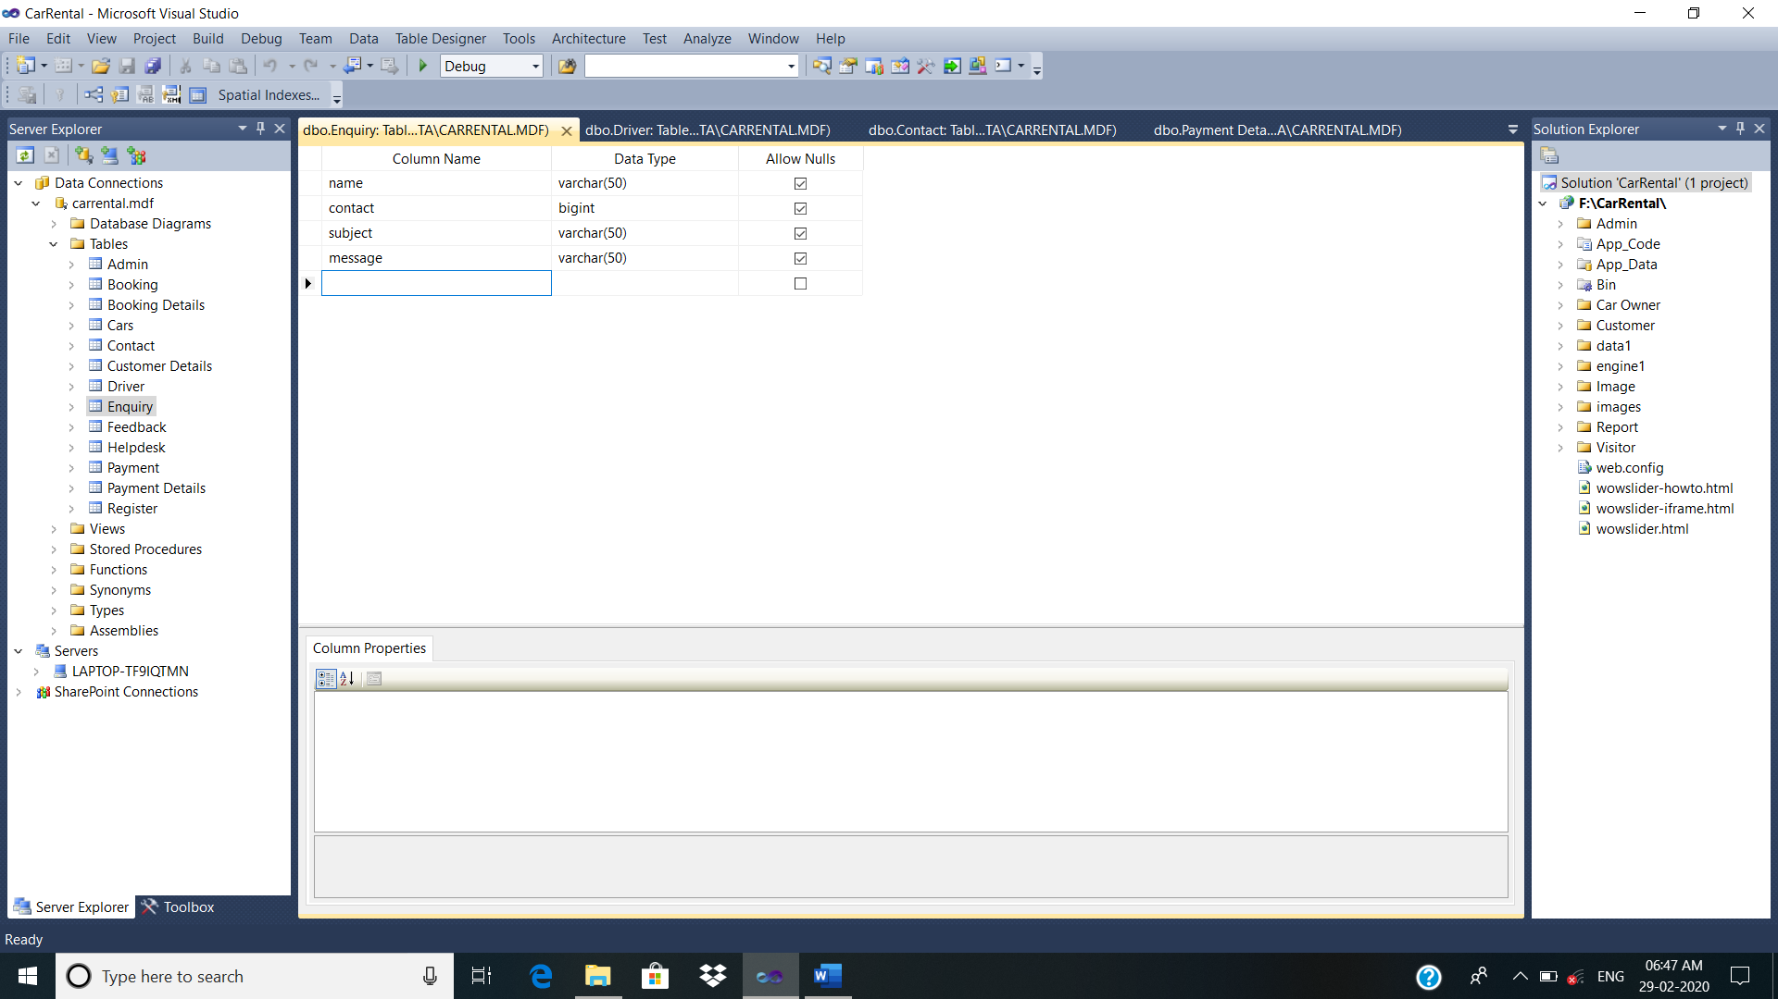

**Table Name: Feedback**

**Description: - To store all Feedback Details**

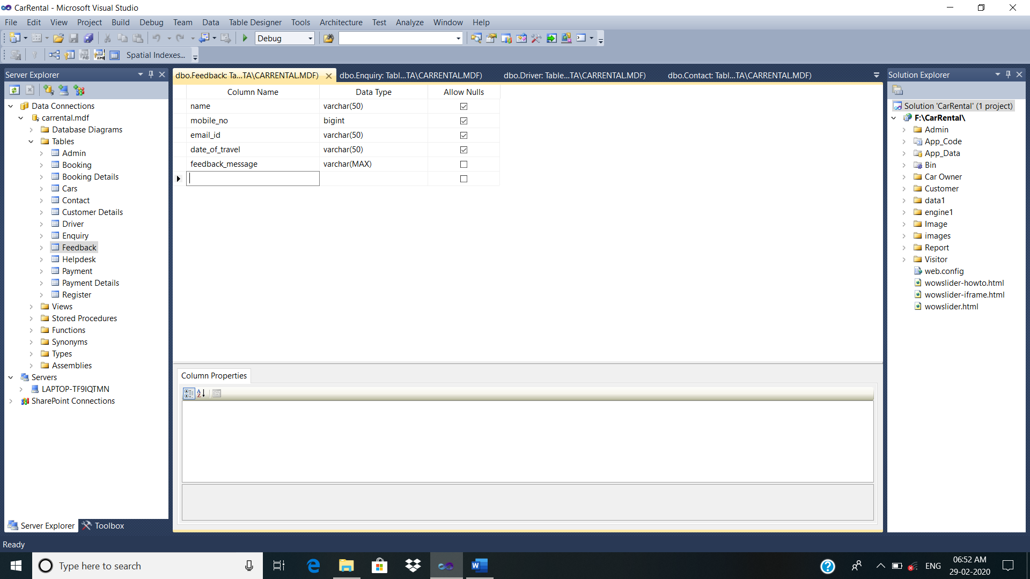

**Table Name: Register**

**Description: - To store all Register Details**

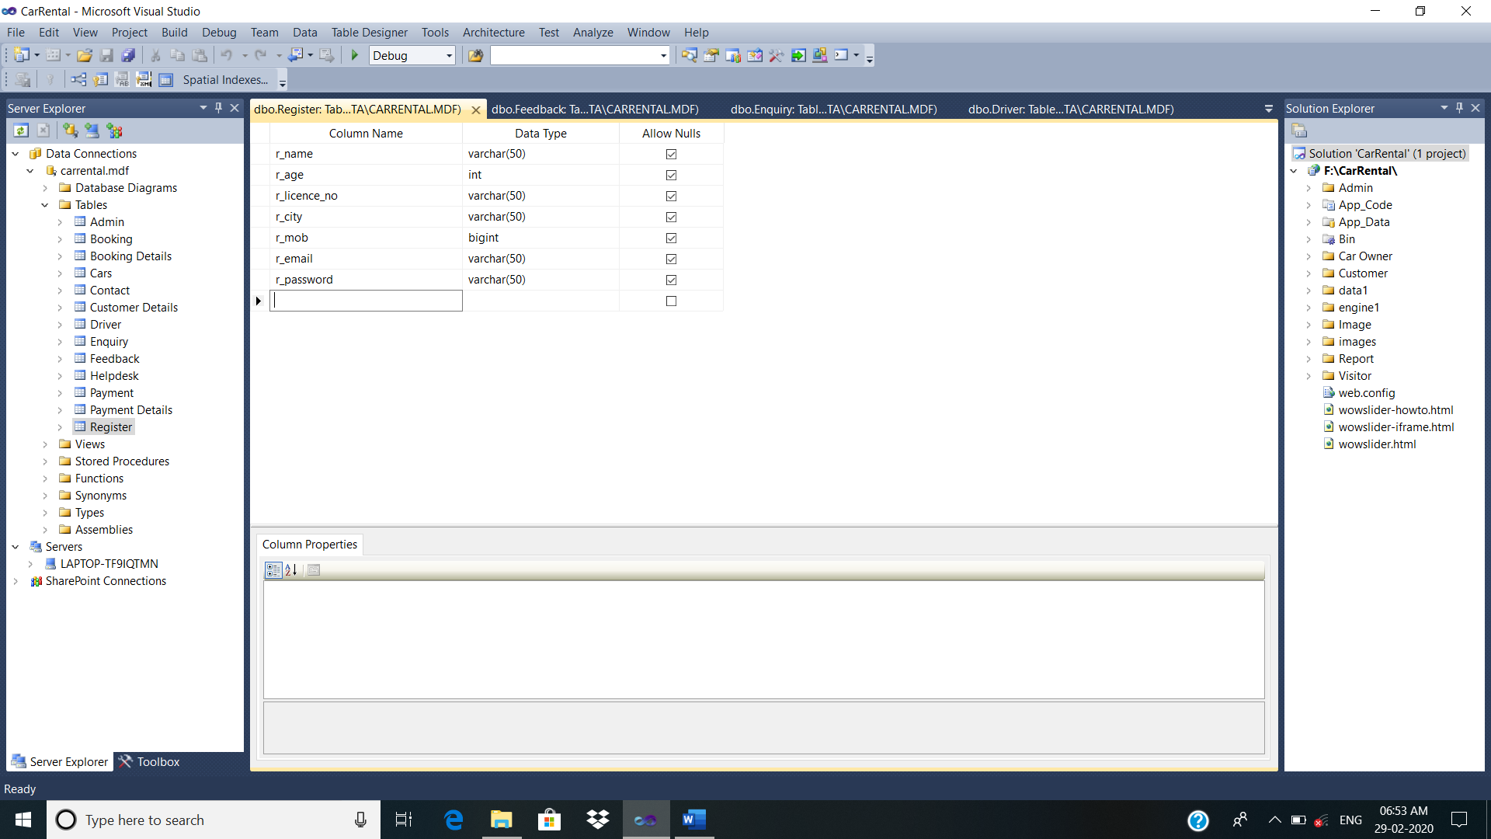

**Input**

**Design**

HOME PAGE:

Description: This page shows Home Page.

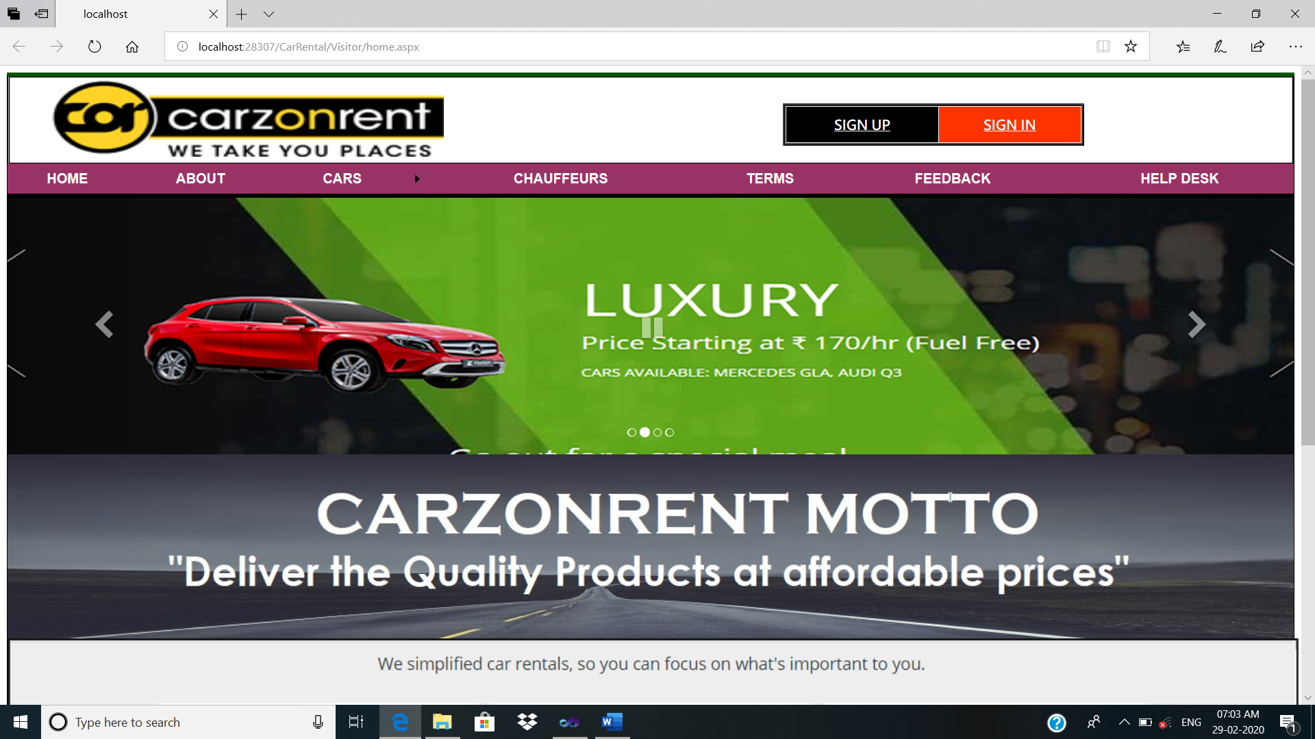

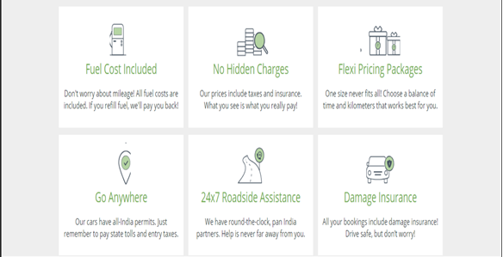

ABOUT US:

Description: This page shows about us.

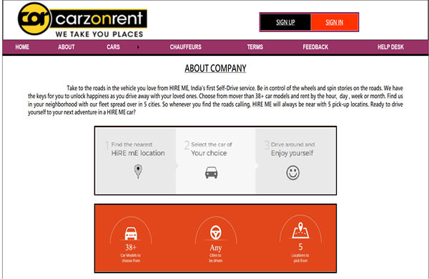

Cars:

Description: This page shows cars.

Hatchback Cars:

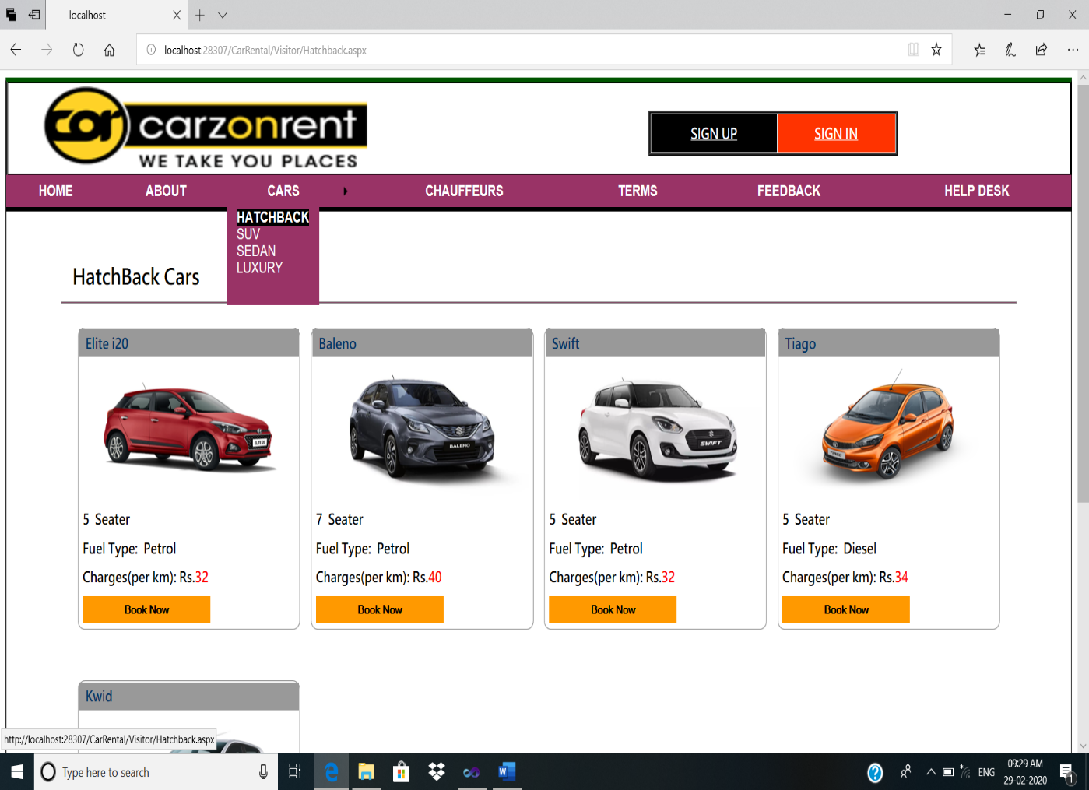

Suv Cars:

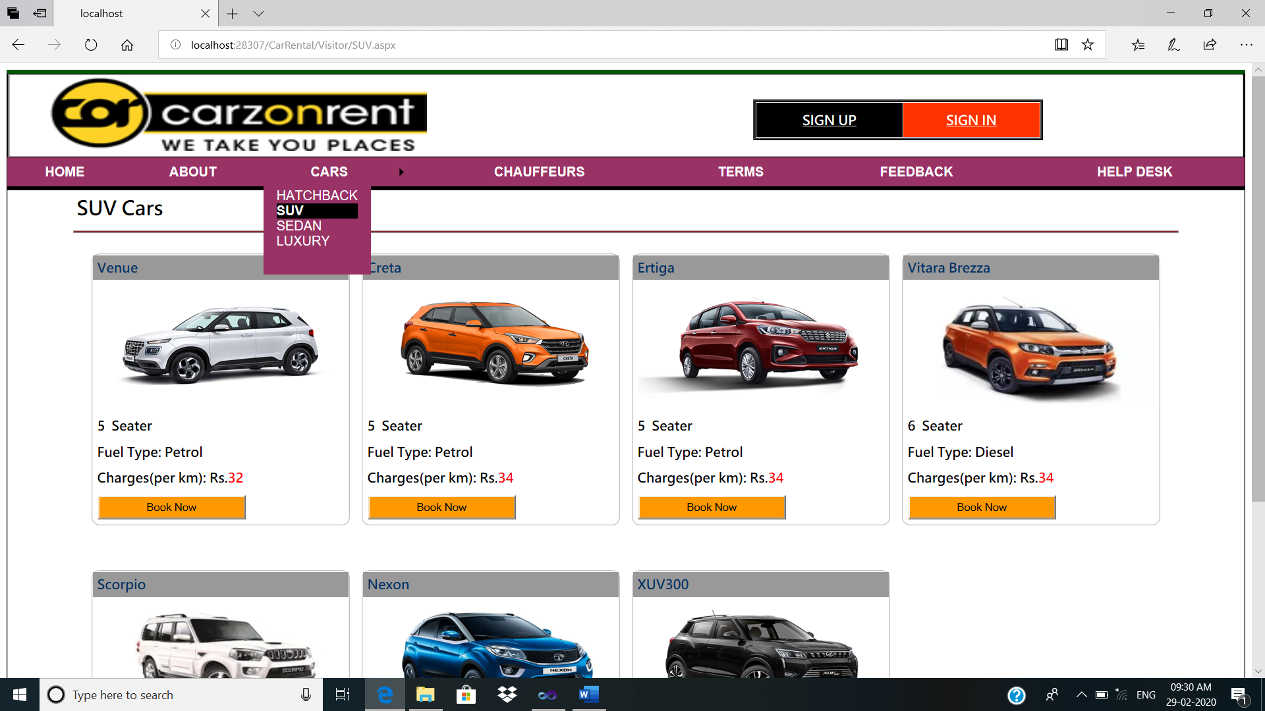

Sedan Cars:

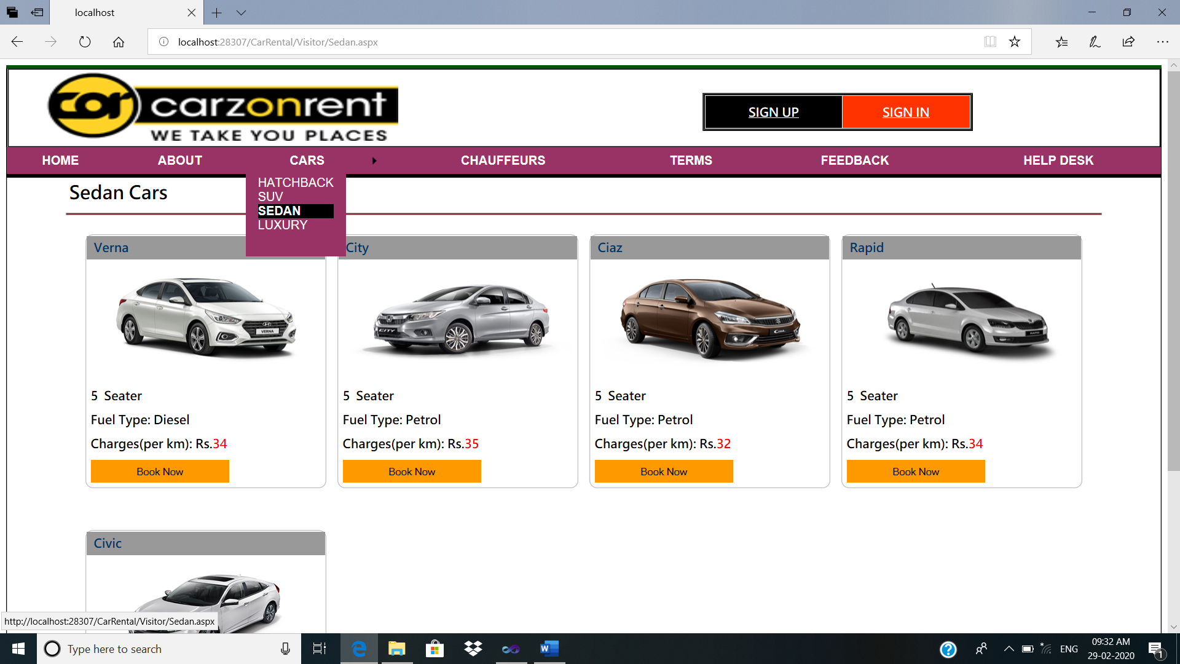

Luxury Cars:

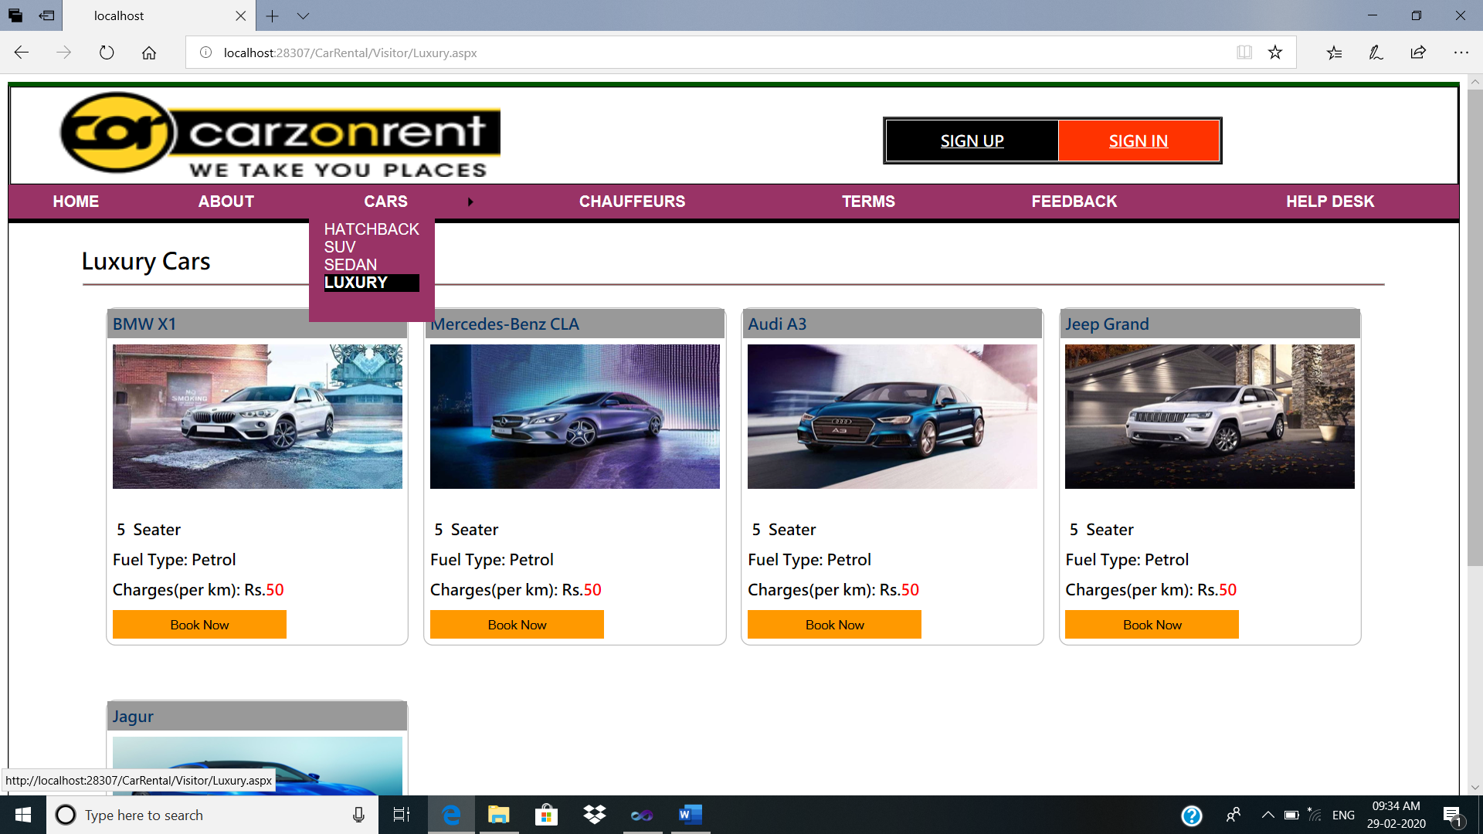

Car Booking Process:

1: Login or register your page

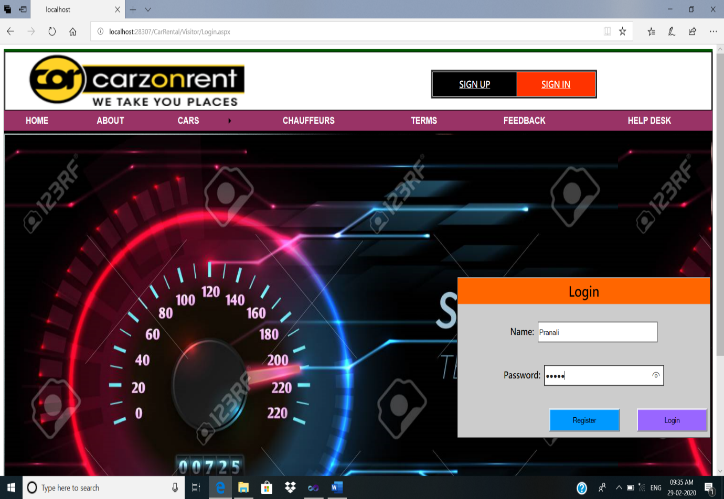

2: BOOKING Details

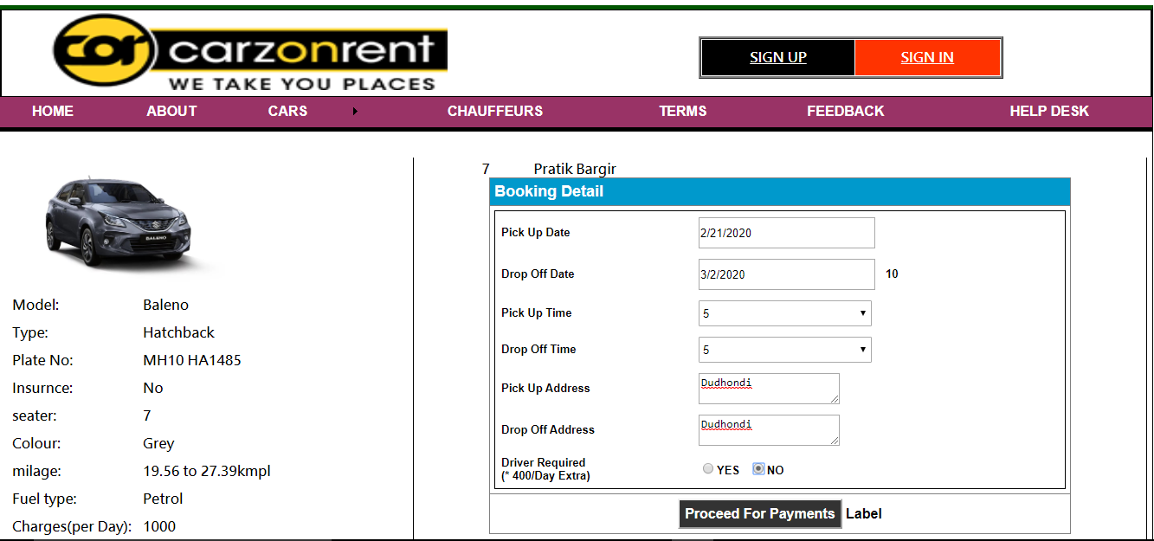

3: PAYMENT Details

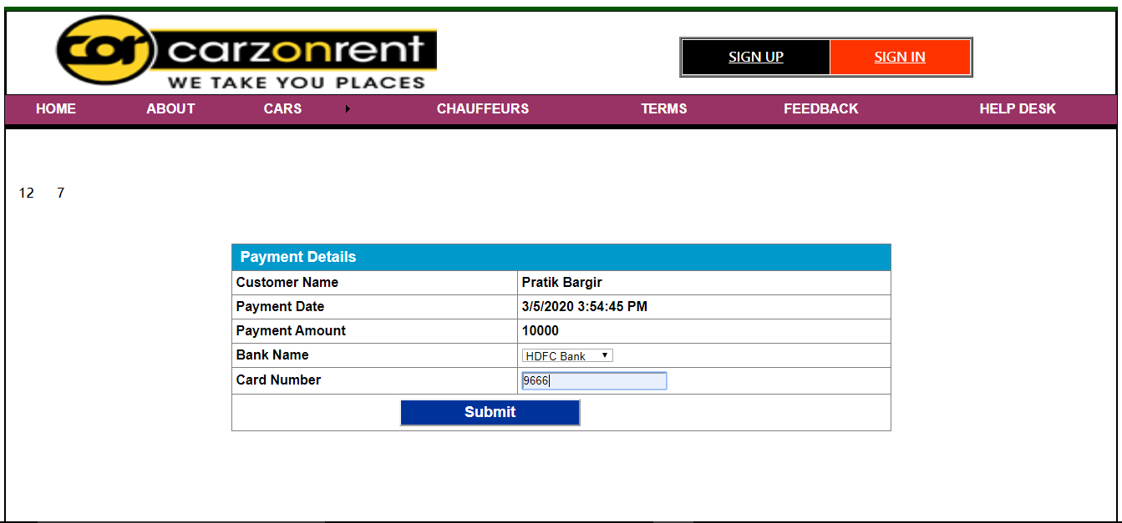

4: Car Book Successfully

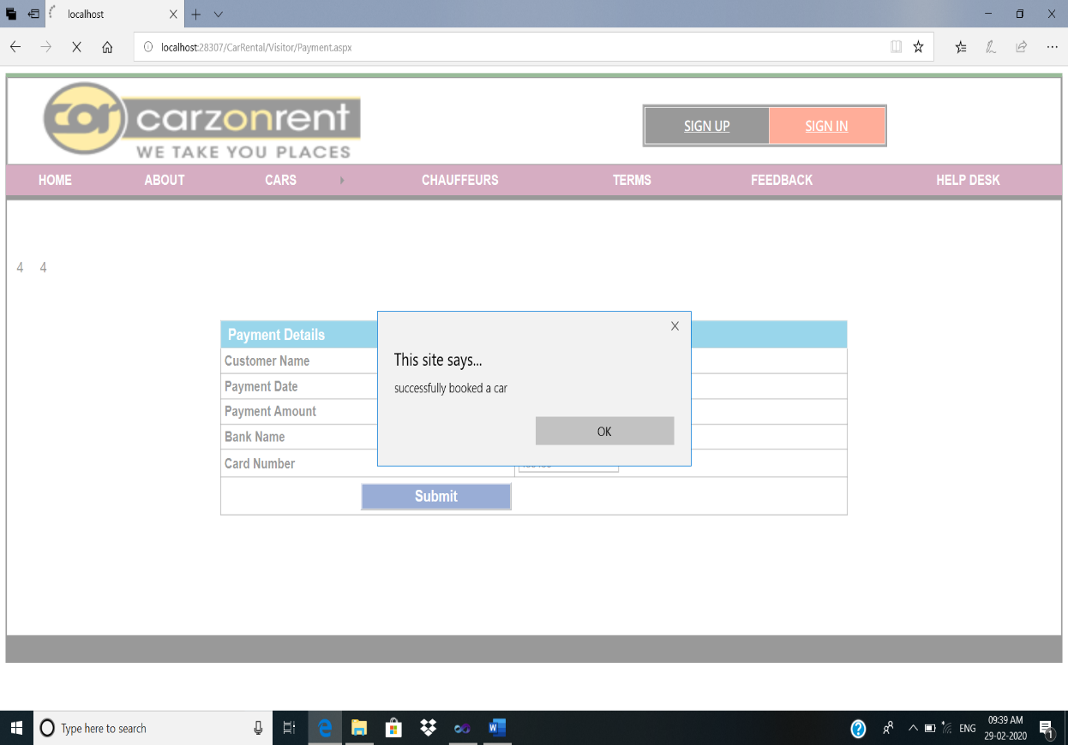

Chauffeurs:

Description: This page shows chauffeurs.

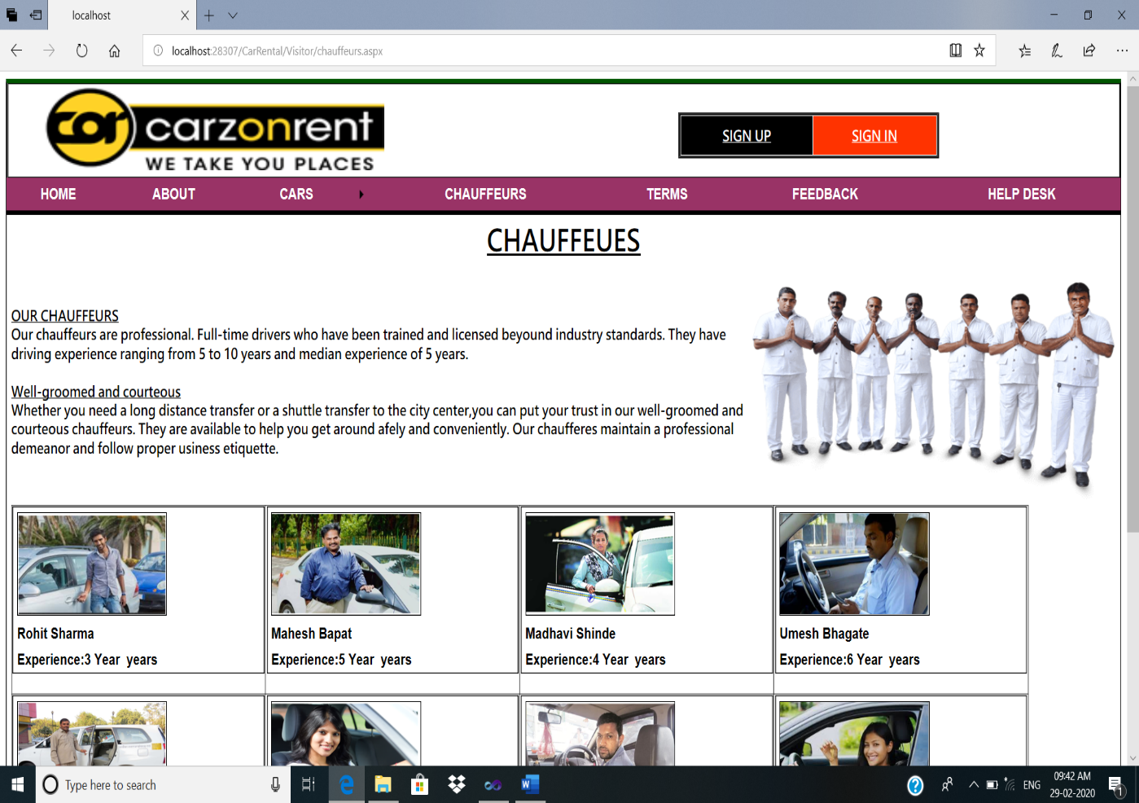

Terms Of Services:

Description: This page shows terms.

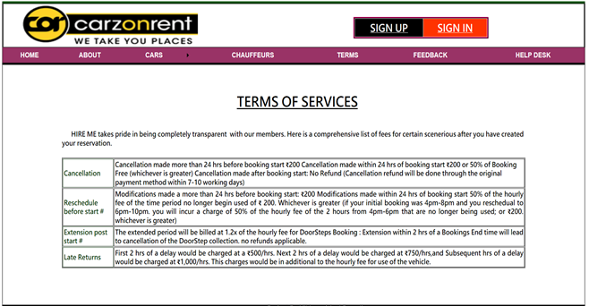

Feedback:

Description: This page shows feedback.

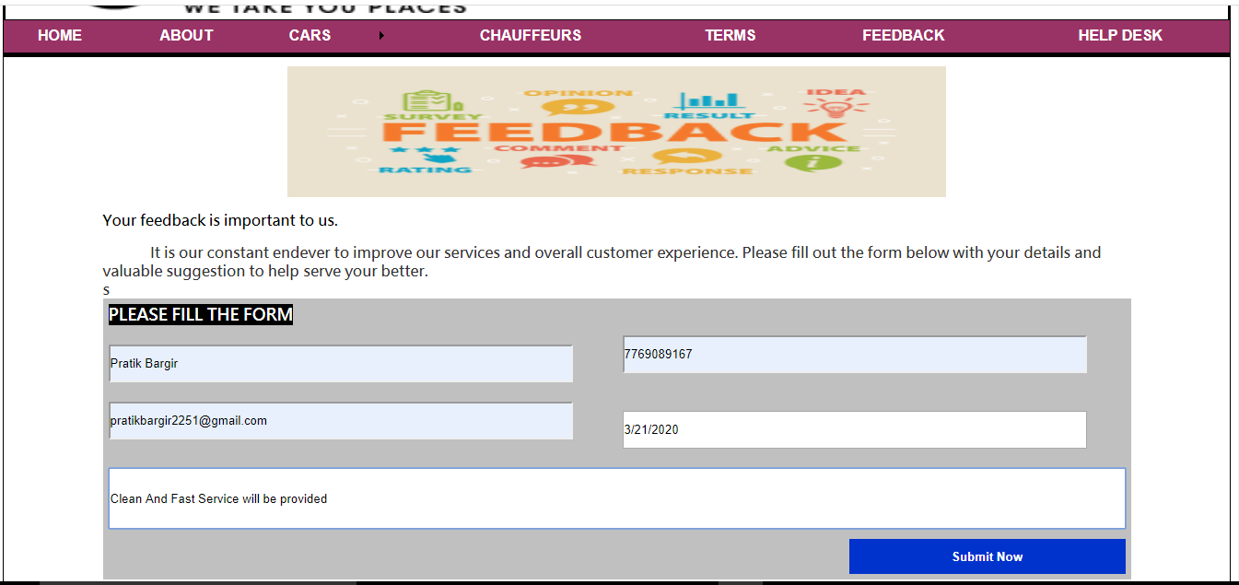

Help Desk:

Description: This page shows help desk.

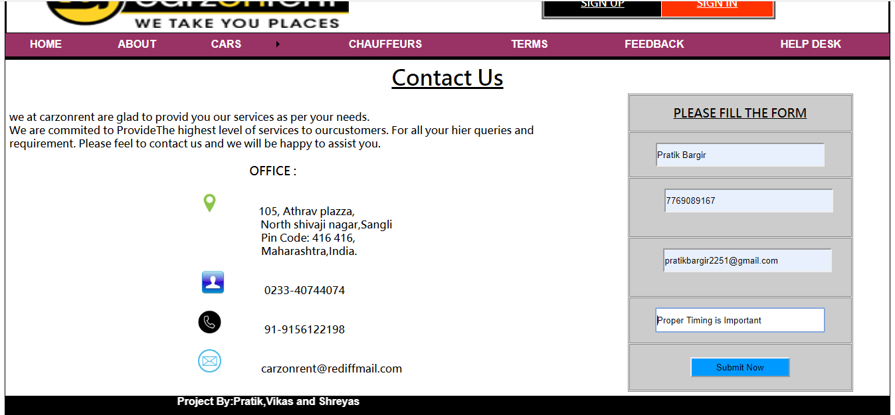

**Admin:**

Description: This page shows admin panel.

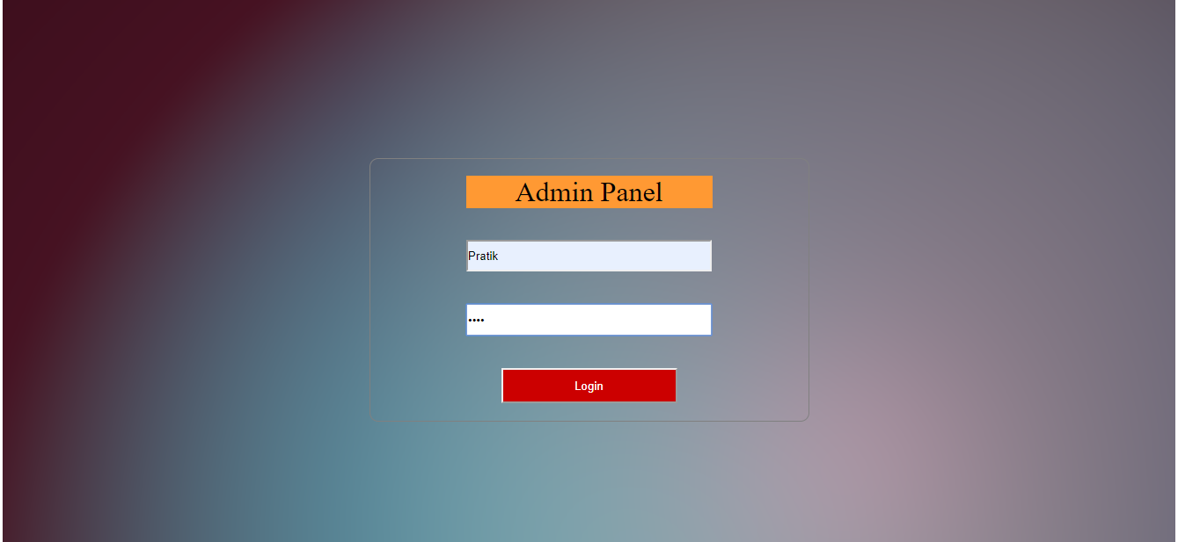

**Manage Car:**

Description: This page shows manage cars.

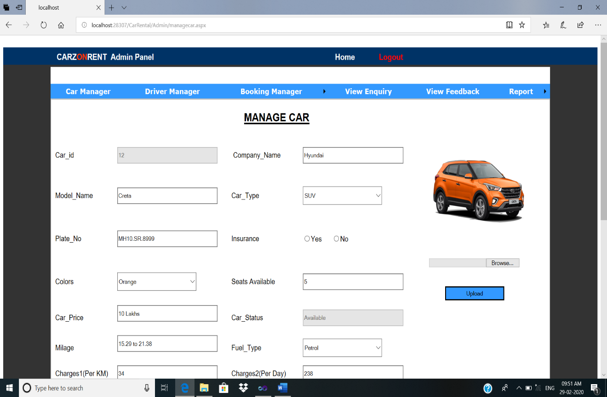

**Manage driver:**

Description: This page shows manage driver.

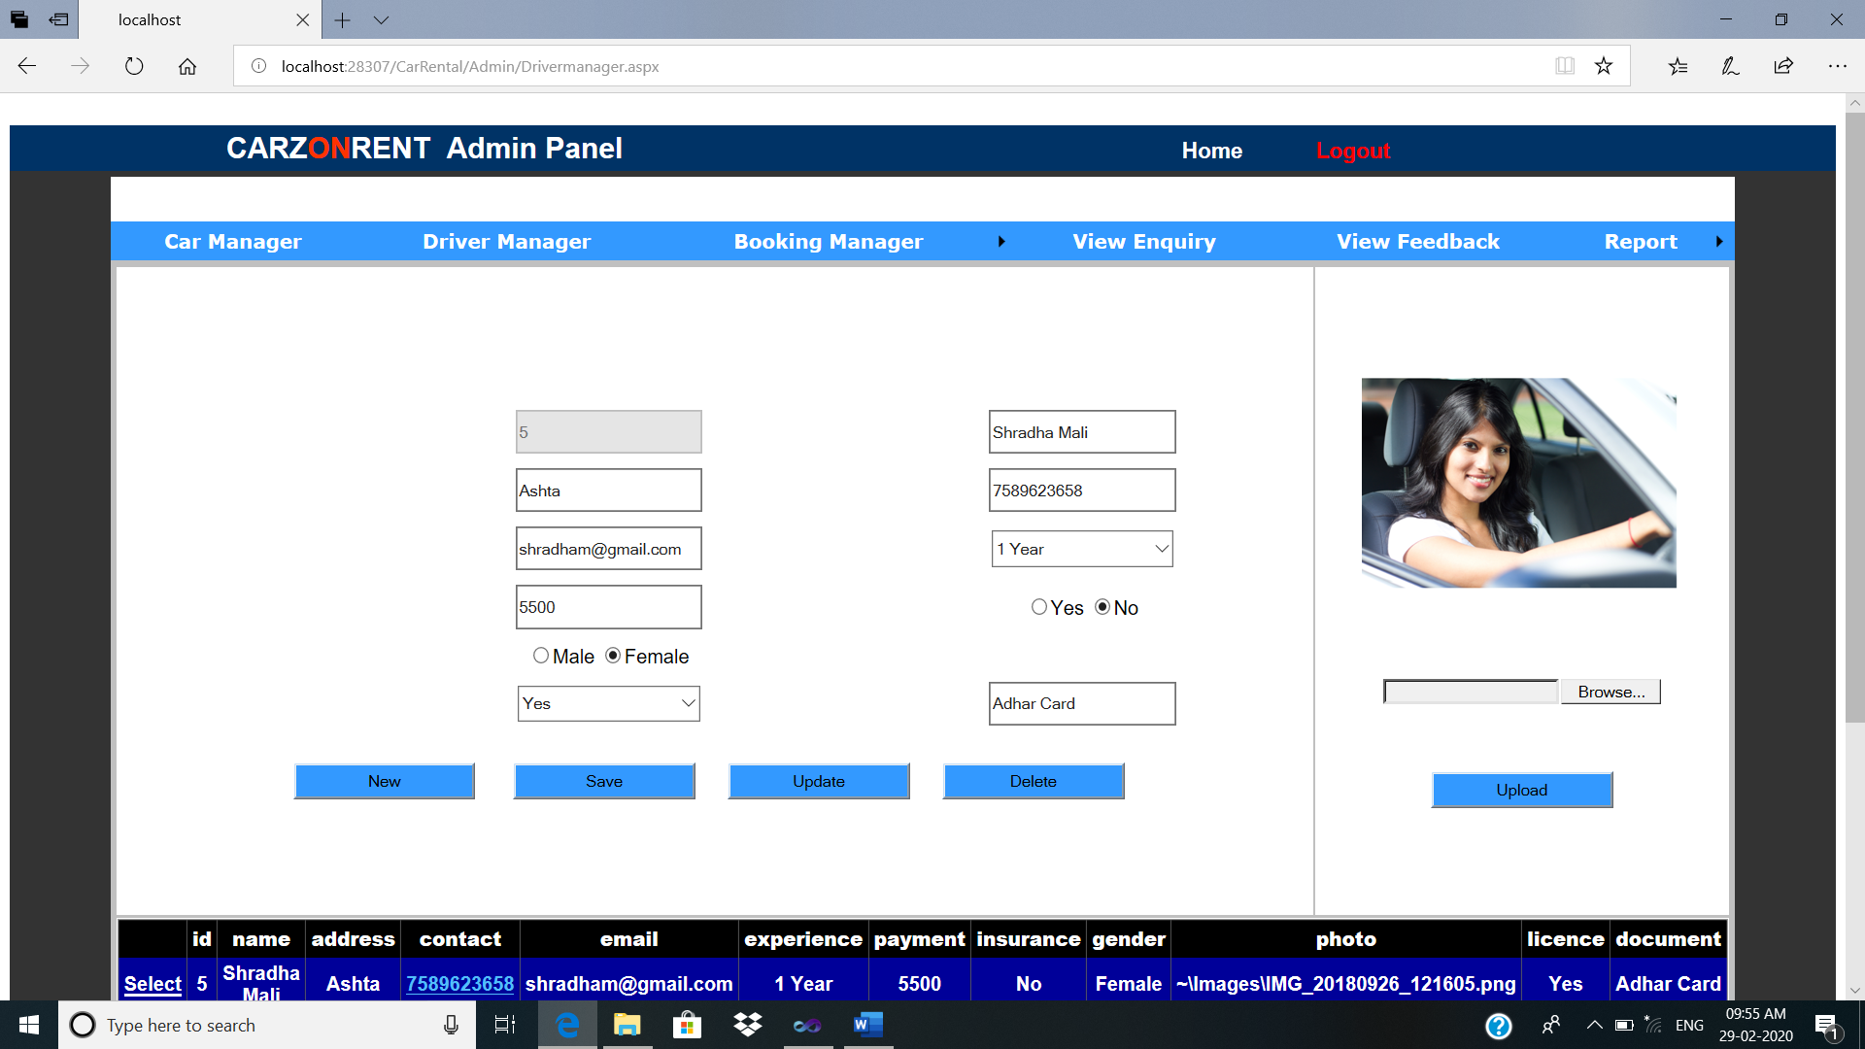

**Booking Manager:**

Description: This page shows booking manager.

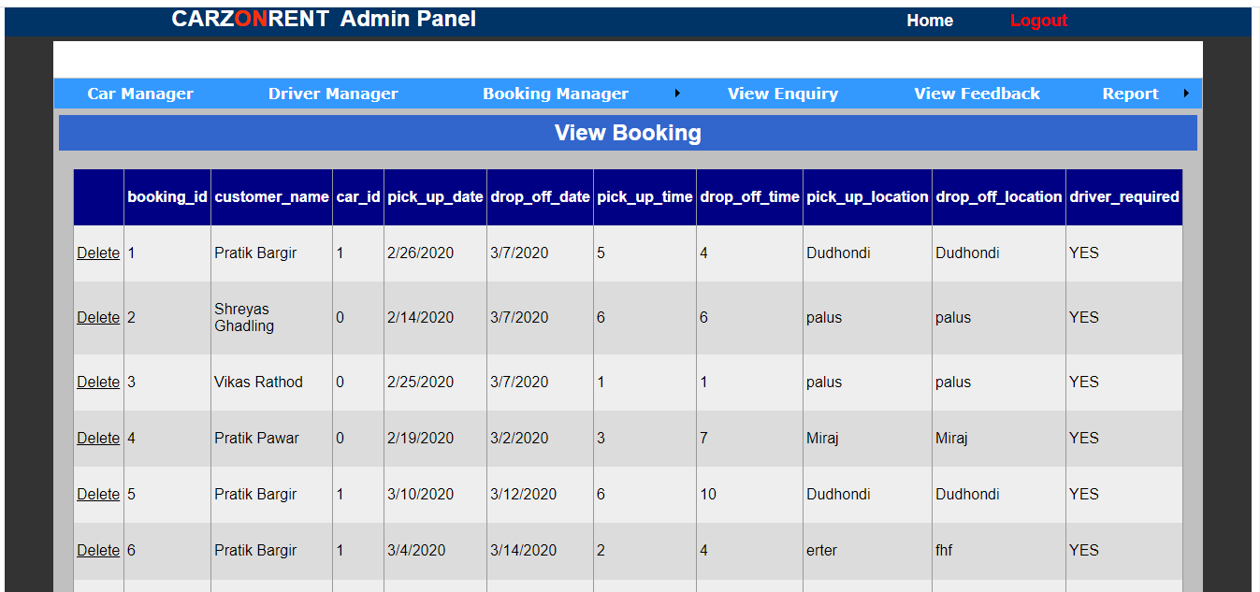

**View Enquiry:**

Description: This page shows view enquiry.

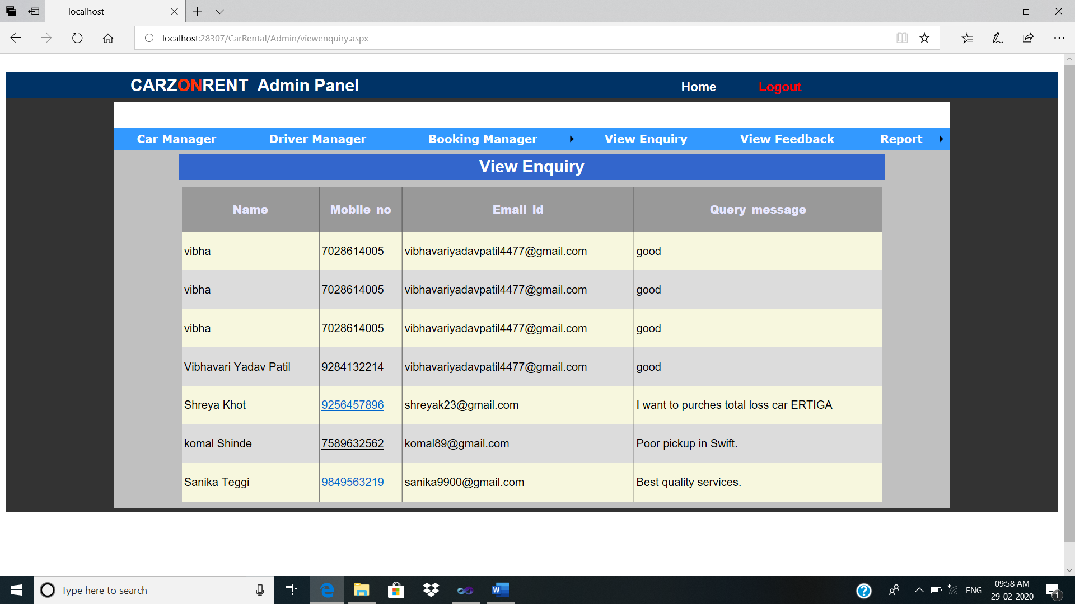

**View Feedback:**

Description: This page shows feedback.

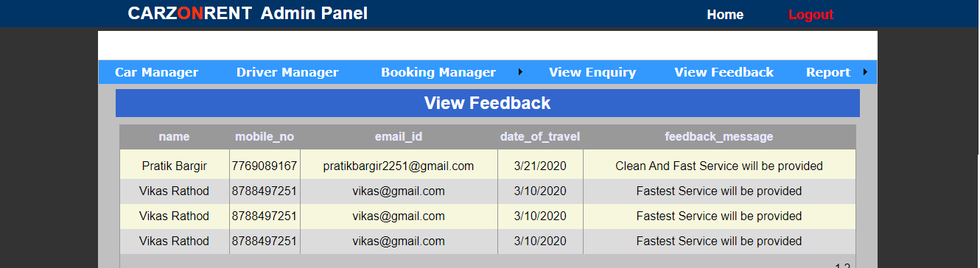

**Report**

**Design**

**REPORT:**

**All Car Report**

**Description**: This is shows car report.

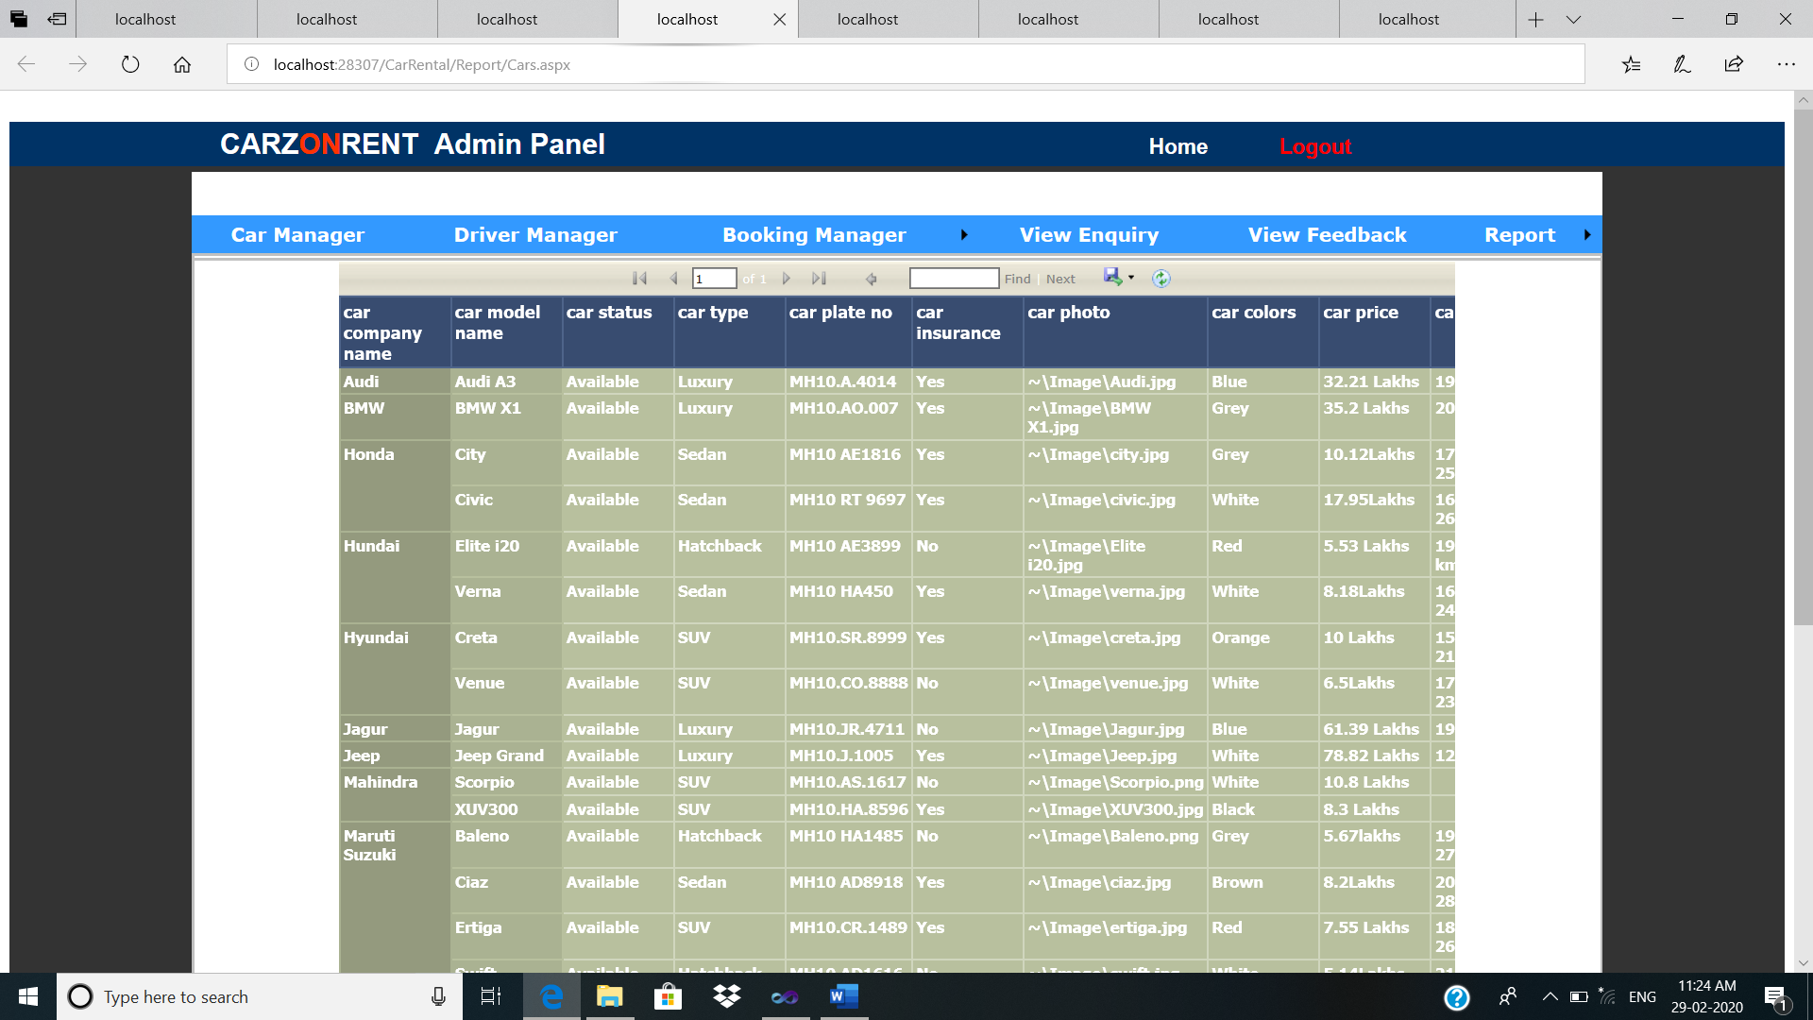

**All Driver Report**

**Description**: This is shows driver report.

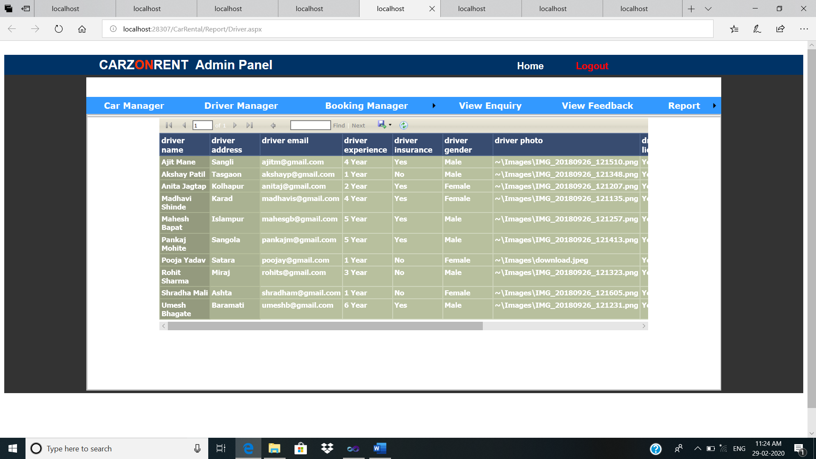

**Feedback Report**

**Description**: This is shows feedback report.

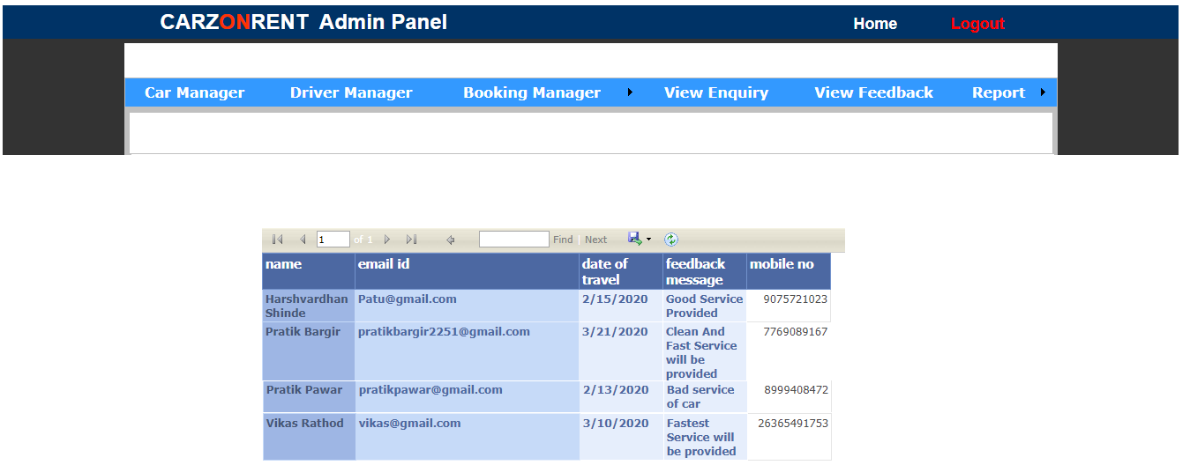

**Register Report**

**Description**: This is shows register report.

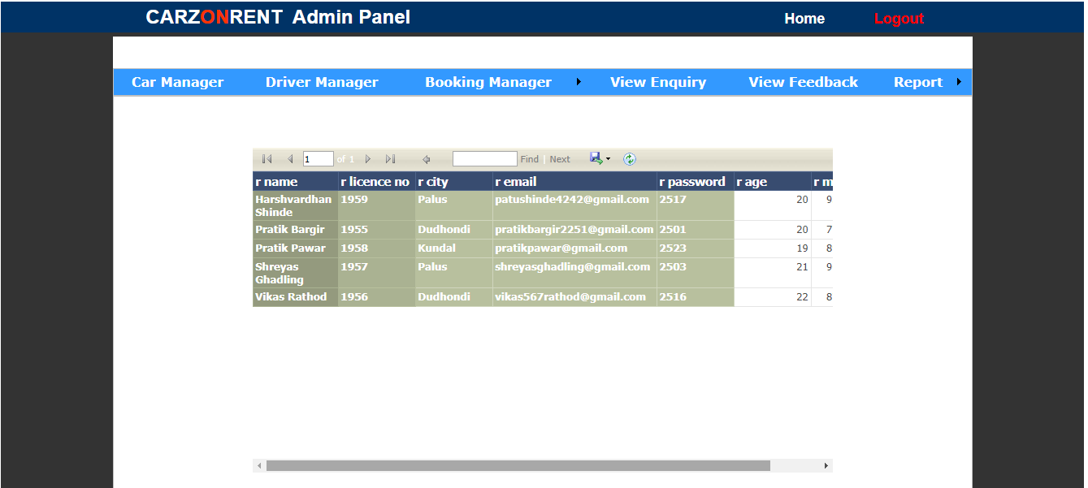

**User**

**Manual**

**\*User Manual:**

The system consist the following modules:

1. Home Master

2. Admin Master

3. Customer Master

The Home Master module consist the following

* Home - It is home page which contains hyperlinks of about us ,services provided, sitemap, contact panel, login.
* About -It is a form having main menu strip contain a forms which are used in the whole system. It contains information about system.
* Cars – It provides all types car information and booking facility to customers.
* Feedback -This form is used for giving feedback of our service.
* Help desk **-**This form is used to get any help related to our website.
* Sign-in **-** This form is used by candidate to login.
* Sign-up – This form is used to register the customer’s account.

The Admin Master module consist the following

* Home - This form is home page used for providing services to admin who has signin.
* Add Cars - This form is used by admin to add cars information.
* Add Drivers - This form is used by admin to add drivers information.
* Manage Bookings- This form is used to manage Booking.
* Change Password - This form is used to change password of admin.
* Report - This shows different reports.
* Logout - this is used to admin logout.

The Customers Master module consist the following

* Home - This form is home page used for providing services to customers who has signin.
* Manage Profile - This form is used for managing Customer’s profile. The candidate can update his/her profile.
* Manage Booking – This form is used for managing customer’s bookings.
* Logout - this is used for candidate logout.



**Future Enhancement**

* Add more car types such as heavy weight cars, buses, etc.
* We can add the hotel booking option in site.
* You can access the website in your mother language.
* We can discover more attractive user interface.
* We can add more cities for customer convince.
* We can add buy voucher option for gift a voucher to your relatives or friends.
* We can add cart for multiple cars booking at same time.
* We can improve security.
* We can add Hire Me points for more discounts to existing customer it can add every time when user can book a car.

**Limitation**

* Once a user gets a car on rent he can’t cancellation of car after rent is allowed.
* We do not OTP generation.



**Conclusion :**

* Thus we have studied about .Net by performing project on online car booking.

In which we have studied various controls available in .Net such as Label, Buttons,

List box etc .

* This project is very useful for getting information about the car of different manufacture. Because now a day’s no one have time to visit that places so visiting this website we get information about the different cars and get the value for money.
* This project is designed in such way that normal person means not a computer literature person can also handle it easily.



**References**

**Book References:**

* Pro ADO.NET with C#.NET

Sahil Malik and Paul Dickinson

* Complete Reference C#.Net

* Visual basic 6 programming (Black Book)

…..Steve Holster

**Web References:**

**Search Engine:** [**www.google.com**](http://www.google.com)

**Related websites:** [**www.Redbus.com**](http://www.Redbus.com)

**www.bookmycar.com**